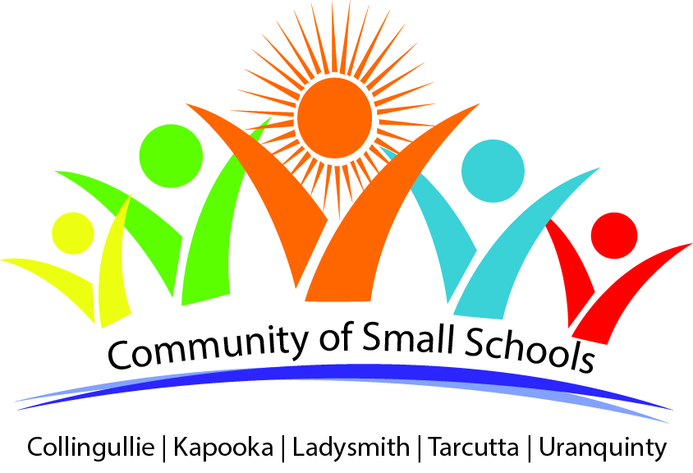
Community of Small Schools Athletic team for WWPSSA Athletics

Dear Parents,
You child has qualified in at least one event for the Wagga Wagga PSSA Athletics carnival on Wednesday 25th May 2016 at Jubilee Park.
Students are to wear their school’s sports uniform, bring a hat and any food they require.
There will be a canteen running all day (run by the Small Schools P & C’s).
Ms Sturman will supervise the students from the Community of Small Schools and will be found near the Community of Schools flag from 9.00am
Students attending are required to pay $2.00 to their respective schools.
Parents are responsible for transporting students to and from Jubilee Park.
Please return permission note to your own school that will pass on any necessary information.
Regards Ms Sturman

My child / children_______________________________________ has/ have permission to attend the Wagga Wagga PSSA Athletics Carnival on Wednesday 25th May 2016 at Jubilee Park.
Emergency contact number on this day___________________________________
I am available to act as a team official on the day and am happy to help on an event. Yes/ no
Event preference.______________________
I understand transport to and from Jubilee Park is my responsibility.
Signed ______________________________ (parent/caregiver) _______________date

